**Practical-9**

**AIM:** To implement the Strassen Matrix Multiplication in C programming.

**SOFTWARE REQUIRED:** Vs Code

**PSEUDO CODE:**

function strassen(A, B):

if size(A) == 1:

return A * B

// Divide the matrices into submatrices

A11, A12, A21, A22 = split(A)

B11, B12, B21, B22 = split(B)

// Calculate the intermediate matrices

M1 = strassen(A11 + A22, B11 + B22)

M2 = strassen(A21 + A22, B11)

M3 = strassen(A11, B12 - B22)

M4 = strassen(A22, B21 - B11)

M5 = strassen(A11 + A12, B22)

M6 = strassen(A21 - A11, B11 + B12)

M7 = strassen(A12 - A22, B21 + B22)

// Calculate the result submatrices

C11 = M1 + M4 - M5 + M7

C12 = M3 + M5

C21 = M2 + M4

C22 = M1 - M2 + M3 + M6

// Combine the result submatrices

C = join(C11, C12, C21, C22)

return C

**CODE:**

#include<stdio.h>

int main(){

  int a[2][2], b[2][2], c[2][2], i, j;

  int m1, m2, m3, m4 , m5, m6, m7;

  printf("Name: Ananta Walli");

  printf("\nEnrollment Number:A2305221322");

  printf("\nEnter the 4 elements of first matrix: ");

  for(i = 0;i < 2; i++)

      for(j = 0;j < 2; j++)

           scanf("%d", &a[i][j]);

  printf("Enter the 4 elements of second matrix: ");

  for(i = 0; i < 2; i++)

      for(j = 0;j < 2; j++)

           scanf("%d", &b[i][j]);

  printf("\nThe first matrix is\n");

  for(i = 0; i < 2; i++){

      printf("\n");

      for(j = 0; j < 2; j++)

           printf("%d\t", a[i][j]);

  }

  printf("\nThe second matrix is\n");

  for(i = 0;i < 2; i++){

      printf("\n");

      for(j = 0;j < 2; j++)

           printf("%d\t", b[i][j]);

  }

  m1= (a[0][0] + a[1][1]) * (b[0][0] + b[1][1]);

  m2= (a[1][0] + a[1][1]) * b[0][0];

  m3= a[0][0] * (b[0][1] - b[1][1]);

  m4= a[1][1] * (b[1][0] - b[0][0]);

  m5= (a[0][0] + a[0][1]) * b[1][1];

  m6= (a[1][0] - a[0][0]) * (b[0][0]+b[0][1]);

  m7= (a[0][1] - a[1][1]) * (b[1][0]+b[1][1]);

  c[0][0] = m1 + m4- m5 + m7;

  c[0][1] = m3 + m5;

  c[1][0] = m2 + m4;

  c[1][1] = m1 - m2 + m3 + m6;

   printf("\nAfter multiplication using Strassen's algorithm \n");

   for(i = 0; i < 2 ; i++){

      printf("\n");

      for(j = 0;j < 2; j++)

           printf("%d\t", c[i][j]);

   }

   return 0;

}

**OUTPUT:**

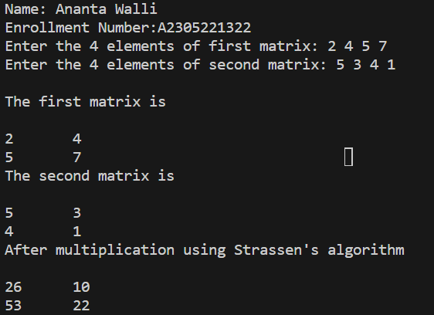

**TIME COMPLEXITY:** The time complexity should be O(n^2.8).

**RESULT:** The above code implements Strassen Matrix Multiplication in C programming.